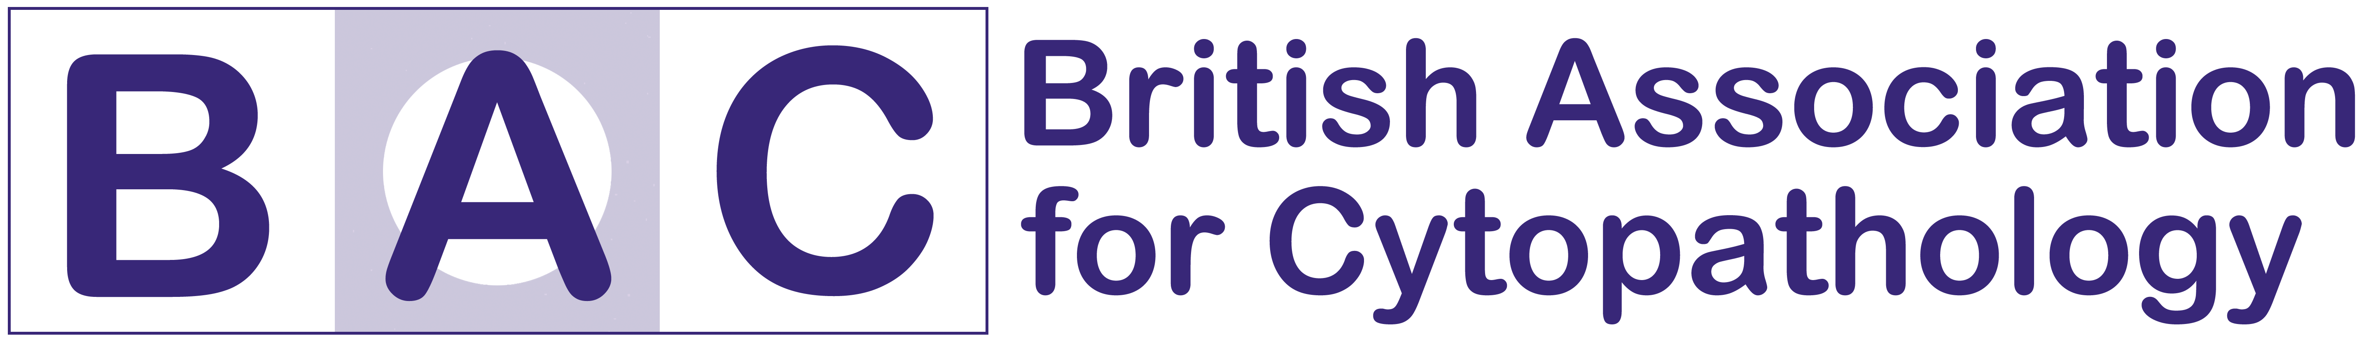

BAC ASM & 10th Anniversary Celebration
DoubleTree Hilton Hotel, Nottingham
Friday 15th October 2021

REGISTRATION FORM

Personal Details
Title | Dr/Mr/Mrs/Miss/Ms/Other (please state)
Full Name
Contact Address
Contact Address |  | Postcode
Contact Telephone
Contact Email Address
BAC membership number if applicable

Registration Fees

Please choose from the options below & note that any non-members can join the BAC and the price is included in the delegate fees.

BAC members
Lectures in-person FREE □
Lectures virtual FREE □
10th Anniversary Dinner & Drinks Reception COMPLIMENTARY □

Non-members
Lectures in-person (includes optional BAC membership*) £50.00 □
Lectures virtual (includes optional BAC membership) £50.00 □
10th Anniversary Dinner & Drinks Reception £30.00 □
*10th Anniversary Dinner is complimentary if you choose to become a BAC member

Registration fee includes coffee, tea, and lunch.
Please indicate in the box below if you have any special dietary or medical requirements:

Payment options

□ I am a self-funder and will send a cheque made payable to BAC

□ I am a self-funder, please send BAC account information for a BACS transfer

□ My employer will pay, and an official purchase order is enclosed with this registration form

GDPR
The information provided by me on this form will not be disclosed to any other party by the BAC and will be used solely for the purposes of managing the meeting

Completed applications and payment should be sent to:

christianburt@ibms.org

COVID-19 Information

Under the Government’s Roadmap out of Lockdown, large meetings such as ASM 2021 will be allowed to take place from 19th July 2021 onwards, however, the situation with COVID-19 restrictions and large gatherings continues to change and will depend upon the situation in England at the time.

In the event that there is a significant increase in infection/transmission rates, Government is likely to re-introduce restrictions, including preventing large gatherings, such as the ASM. This could be at short notice.

BAC are working under the assumption that this event will be allowed to proceed and are working with the venue to deliver an enjoyable and informative, COVID-safe event, however, should the situation change, the following scenarios are possible:

- Cancellation by the venue due to Government restrictions – delegates will receive a full refund or credit on their account for events after the planned date of ASM 2021

- Cancellation by the delegate due to localised Government restrictions (for example Tiers are back in place on the day of the event) meaning that individual delegates may not be able to attend due to their location – delegates may cancel beyond the closing date and have the option to receive a full refund or credit on their account for the event. Alternatively, their place may be transferred to a named professional who can attend ASM 2021, at no extra charge

- Postponement of the event due to Government restrictions – delegates will have the option to receive a full refund or credit on their account for the event.

Refunds and credit on account will only be applied once full payment has been received, and will only apply to services booked via BAC, after the date of the planned event.

ADVISORY
When planning travel consider short notice cancellation is possible.

