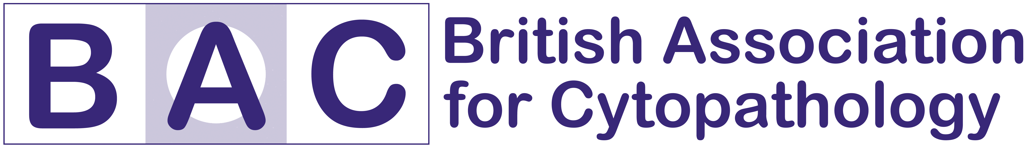
DoubleTree Hilton Hotel, Nottingham
BAC Annual Scientific Meeting & 10th Anniversary Celebration
15th October 2021

Company Details
Named Delegate 1
Named Delegate 2
Company Name and
Contact Address
Company Name and  Contact Address |  | Postcode
Contact Telephone
Contact Email Address
On-site mobile number &
contact for deliveries
Logo attached for website  (JPEG) | Please send with completed application

Stand Requirements
Electrical point required? | Yes/No
Table & Chairs required?  (tablecloth not supplied) | Yes/No
Trade Stand Size 3x2m only | Yes/No
Trade Stand Size Double required (limited number) | Yes/No

Payment options and total cost
Item | Tick if applicable | Cost
Trade Stand 3x2 (physical attendance) |  | £250.00
Trade Stand Double (physical attendance) |  | £400.00
Company / Product Presentation (virtual on-screen)* |  | £200.00
Company Logo Displayed (virtual on-screen)* |  | £150.00
Bag insert / promotional material |  | £100.00
TOTAL COST
* Presented on-screen during breaks and lunch
GDPR
The information provided by me on this form will not be disclosed to any other party by the IBMS and BAC and will be used solely for the purposes of managing the meeting

Completed applications and payment information should be sent to:

Email: christianburt@ibms.org

COVID-19 Information

Under the Government’s Roadmap out of Lockdown, large meetings such as ASM 2021 will be allowed to take place from 21st July 2021 onwards, however, the situation with COVID-19 restrictions and large gatherings continues to change and will depend upon the situation in England at the time.

In the event that there is a significant increase in infection/transmission rates, Government is likely to re-introduce restrictions, including preventing large gatherings, such as the ASM. This could be at short notice.

BAC are working under the assumption that this event will be allowed to proceed and are working with the venue to deliver an enjoyable and informative, COVID-safe event, however, should the situation change, the following scenarios are possible:

- Cancellation by the venue due to Government restrictions – exhibitors will receive a full refund or credit on their account for events after the planned date of ASM 2021

- Cancellation by the delegate due to localised Government restrictions (for example Tiers are back in place on the day of the event) meaning that individual delegates may not be able to attend due to their location – exhibitors may cancel beyond the closing date and have the option to receive a full refund or credit on their account for the event. Alternatively, their place may be transferred to a named professional who can attend ASM 2021, at no extra charge

- Postponement of the event due to Government restrictions – exhibitors will have the option to receive a full refund or credit on their account for the event.

Refunds and credit on account will only be applied once full payment has been received, and will only apply to services booked via BAC, after the date of the planned event.

ADVISORY
When planning travel consider short notice cancellation is possible.

